Trail Me About It
Fund
A supported program of the Tuolumne County Transportation Council
===============================================================

Funding paths in Support
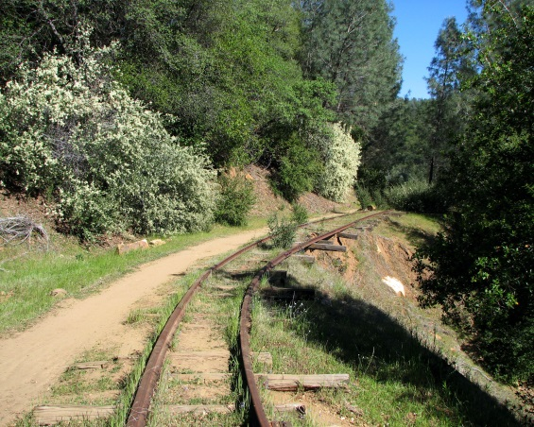
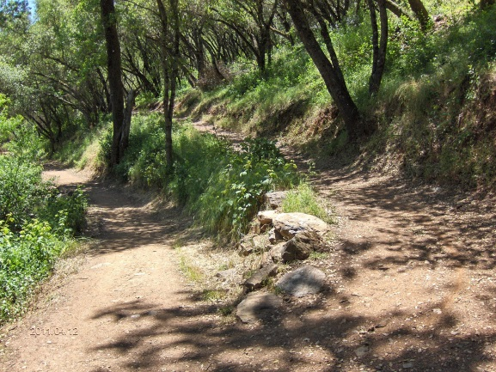
of
maintenance, improvement, enhancement, and safety.

A Field of Interest Fund administered by the Sonora Area Foundation that provides mini-grants to qualified non-profit organizations assisting in Tuolumne County non-motorized trail improvements and enhancements.

The fund readily accepts tax deductible contributions to assist in making grants for such good work.
========================================================================================
Our Trails

Tuolumne County, nestled in the central portion of the Sierra Nevada (the longest unbroken chain of mountains in America) is the regional home to exceptional natural resources, rivers, peaks, meadows, canyons, reservoirs, alpine forests and rolling oak woodlands. Put simply, Tuolumne County is an outdoor wonderland!
With this said, trails of the greatest value to communities are those located within close proximity to residences and community destinations. Trails not overly distant are trails that generate the greatest use and resultant health benefits, social and economic benefits, and corresponding community pride.
The Provision

Many of our Tuolumne County trails have community stewards that often invest their own time and money for maintenance, improvement, enhancement, and safety. However, they often need added resources to assist them in this work; a mini-grant program.

The “Trail me about it” Fund

A local grant making program designed to support small scale improvements driven by community or social service organizations, such as:
- Trail head kiosks, sign posts and trail markers
- Interpretative signage
- Trail parking or access improvements
- Trail maps and brochures
- Trail Planning
- Trail maintenance
- Trail extensions
- Trail amenities: picnic tables, trash receptacles, doggie bag dispensers
- Other similar enhancements and improvements

Applying for a Mini-Grant

The “Trail Me About It” Review committee, chaired by Tyler Summersett of Tuolumne County Trails, www.tuolumnecountytrails.com will review grant applications and recommend those consistent with funding goals to the Sonora Area Foundation which has ultimate authority for all grantmaking.

The Review Committee operates in a timely manner and decisions are usually made within four weeks of application.

If your organization wishes to be considered for a mini-grant up to $1,500 please complete the following application and budget and
Email to: tsummersett@co.tuolumne.ca.us
Tyler Summersett
Tuolumne County Trails
Phone: 209-533-5557

Grant recipients are expected to expend the funds awarded in a timely fashion. Grantees are encouraged to reflect their proposed timelines as closely as possible. Extensions can be granted when extenuating circumstances are encountered.

After all awarded funds have been expended and the project is complete, the Trail Me About It program, asks that within 60 days, the following be provided:

1. A short project narrative outlining what was accomplished (half page)
2. A photo of the improvement or electronic documentation of whatever was produced

Making a contribution to the Fund

The “Trail Me About It” Fund is a component fund of the Sonora Area Foundation and seeks to provide mini-grants to enhance and improve non-motorized trails in Tuolumne County. The success of the program is based in tax deductible contributions to the Fund by donors. AND all dollars donated to the Fund go for the mini-grants. The Sonora Area Foundation does not take any fees. A dollar to the Fund is a dollar to Trails.

Contributions may be made:
Through PayPal at www.tuolumnecountytrails.com or www.sonora-area.org

or by check payable to:
Sonora Area Foundation
362 So Stewart Street
Sonora, CA 95370
--- Indicate on the “memo” line of the check: Trail Me About It Fund

The Sonora Area Foundation is a tax-exempt organization under Section 501(c)(3) of the IRS code. Tax ID# 93-1023051
Trail Me About It Fund
Mini-Grant Application
Maximum $1,500 for non-motorized trails in Tuolumne County

Applying Organization _______________________________________ EIN ___________________

Project Contact Person _________________________________________________________________

Mailing Address ______________________________________________________________________

Daytime telephone number _________________ Email ______________________________________

Project Name _________________________________________________________________________

Trail or Project Location ________________________________________________________________

Amount Requesting $ _________________

Add a One-Page Narrative including the following information; description of the project (including, if applicable, other participating organizations) volunteer and community involvement, timeline of the project, any needed clarification of the budget, and how the project will benefit the Trail.

Complete and attach the Budget Page

By checking the box you agree to provide a project report within 60 days of completion

COMMITTEE REVIEW DATE: ______________

COMMITTEE MEMBER NAMES: ________________________________________________________

__________________________________________________________________________________

Committee action: Approval Amount (up to $1,500) _____________ Deny ______

COMMITTEE CHAIR SIGNATURE__________________________ DATE: __________

